**CD Lab Assignment-3, 9th Aug**

**122CS0088, Gautham Sai Mittapalli**

1. Design string recognizers using Flex tool for following

(a) Strings of a's and b's

where |n(a)-n(b)| mod 3 = 0.

n(a) and n(b) are number of a's and

b's, respectively.

(b) Integer constants in C language.

Example: -125, 125, 125U, 123L, 0x4ABF, 0723.

(c) Floating point constant in C language.

Example: 0.25, 0.25f, 2.5E-1

Q1a)

**Code: -**

%{

#include <stdio.h>

#include <stdlib.h>

int a = 0, b = 0;

%}

%%

"a" { a++; }

"b" { b++; }

. { return 0; }

\n {

if ((abs(a - b) % 3) == 0)

printf("String is Accepted\n");

else

printf("String Rejected\n");

a = 0; b = 0;

}

%%

int yywrap() {}

int main() {

while(yylex());

printf("Enter Valid String\n");

return 0;

}

**Output:-**

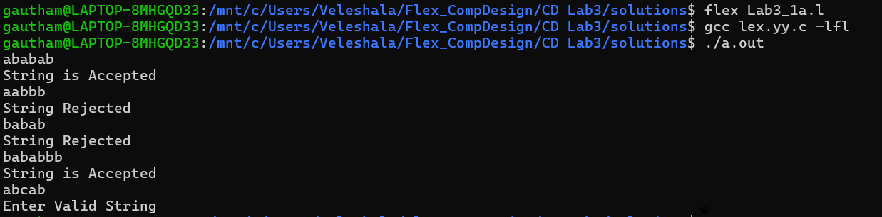

Q1b)

**Code: -**

%{

#include <stdio.h>

#include <stdlib.h>

int state = 0;

%}

%%

0[xX][0-9A-Fa-f]+ {printf("Hexadecimal Integer: %s\n", yytext);}

0[0-7]+ {printf("Octal Integer: %s\n", yytext);}

[0-9]+[uU]? {printf("Decimal Integer: %s\n", yytext);}

[0-9]+[lL]? {printf("Long Integer: %s\n", yytext);}

-?[0-9]+[Uu]? {printf("Signed Decimal Integer: %s\n", yytext);}

. {printf("Invalid\n");}

%%

int main(){

yylex();

return 0;

}

int yywrap(){}

**Output: -**

Q1c)

**Code: -**

%{

#include <stdio.h>

%}

%%

[0-9]*\.[0-9]*[fF]? { printf("%s is in Fractional format\n", yytext); }

[0-9]*\.[0-9]*([eE][-+]?[0-9]+)?[fF]? { printf("%s is in Exponential number in fractional format\n", yytext); }

[0-9]+[eE][-+]?[0-9]+[fF]? { printf("%s is in Exponential format\n", yytext); }

. { printf("Invalid\n");}

%%

int main() {

yylex();

return 0;

}

**Output: -**

